EWMA correlation: GBPUSD and NZDUSD
Method 06 / daily log returns / lambda = 0.94 / Alpari D1 full available history

Study setup
Logical pair: GBPUSD , NZDUSD
Broker symbols: GBPUSD_i , NZDUSD_i
Snapshot: 2026-11-03_majors_alpari_D1
Timeframe: D1
Matched return window: 1999-01-05 to 2026-11-02 (UTC bar dates)
Matched return count n: 7203
Dropped unfinished last bar dated 2026-11-03 UTC after a tick-volume check against the prior complete day.
Lambda: 0.94 (today weight 0.06)
Burn-in ignored in path summaries and chart: first 60 updates
Mean adjustment: each leg demeaned by its mean on the matched rows
Seeds: c_0 = v_x,0 = v_y,0 = 0
Complete matched rows (Excel): GBPUSD-NZDUSD_EWMA_D1.xlsx
Complete matched rows (HTML table): GBPUSD-NZDUSD_EWMA_D1_data.html

Method carried forward
EWMA correlation updates covariance and variances of mean-adjusted daily log returns of close, ln(close_t / close_t-1), with lambda = 0.94 (6% weight on today's product or square, 94% on yesterday's EWMA state). Quotes are not inverted. Each leg is demeaned by its mean on the matched rows; that mean uses the full sample, so the rho path is a full-sample description, not a live filter. Seeds start at zero. Path summaries and the chart ignore the first 60 updates so the zero seed has faded. The headline is rho on the last day. rho is symmetric under swap of the two symbols. A high |rho| does not prove cause, lead-lag, or a trading signal. Today's return sits inside today's rho, so the estimate can only inform a later decision. Same-sample Pearson r is a side check only.

Results
Latest EWMA rho: 0.520720
Post-burn-in path (n=7143): mean=0.507829, median=0.537658, min=-0.326118, max=0.913643, std=0.219902
Share of post-burn-in days with |rho| >= 0.4: 69.58%; |rho| >= 0.7: 22.25%
Same-sample Pearson r: 0.530079
Latest rho minus r: -0.009359

Conclusion
Over 7203 matched daily log-return rows for GBPUSD and NZDUSD (broker quote directions unchanged), latest EWMA rho with lambda=0.94 is 0.5207 (positive, moderate recent linear link in this sample). After a 60-day burn-in, path mean is 0.5078, std is 0.2199, and the range is [-0.3261, 0.9136]. Same-sample Pearson r is 0.5301 (latest rho minus r = -0.0094). This does not establish cause, lead-lag, or a lasting trading rule.

Charts
Daily closes

Daily log returns
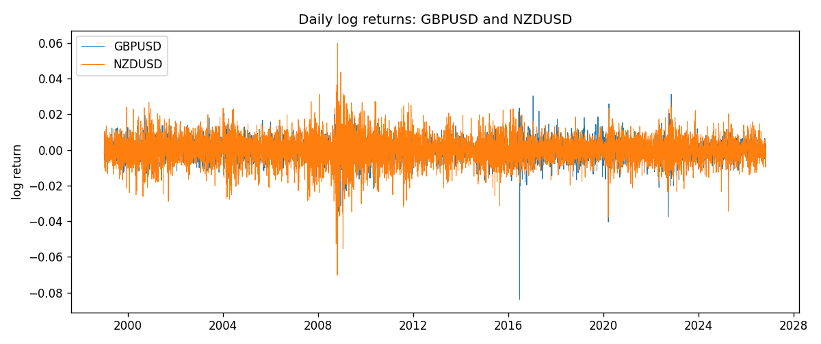
EWMA rho path with Pearson r reference
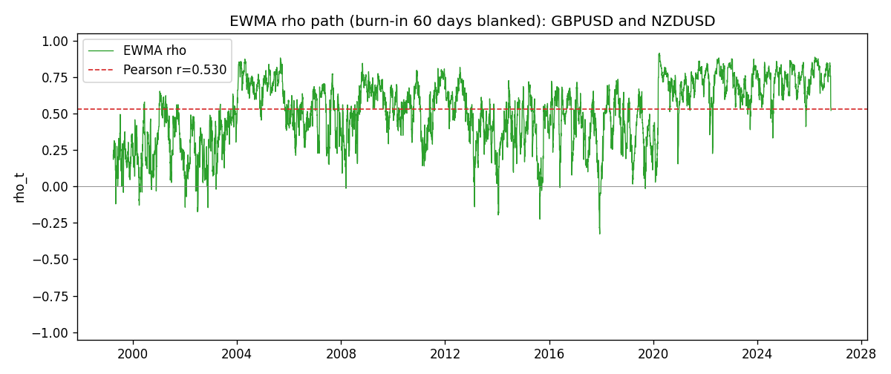

Data report
Every matched row that entered the EWMA recursion is stored in the sibling Excel workbook named GBPUSD-NZDUSD_EWMA_D1.xlsx. That file is the complete data archive for redrawing charts. Embedding all rows as a Word table is impractical at this length; the Word file holds the column list, column summaries, and the first and last 15 matched rows.
Columns: time, GBPUSD_open, NZDUSD_open, GBPUSD_high, NZDUSD_high, GBPUSD_low, NZDUSD_low, GBPUSD_close, NZDUSD_close, GBPUSD_tick_volume, NZDUSD_tick_volume, GBPUSD_spread, NZDUSD_spread, GBPUSD_real_volume, NZDUSD_real_volume, GBPUSD_log_return, NZDUSD_log_return, GBPUSD_x_demeaned, NZDUSD_y_demeaned, c_t, v_x, v_y, rho_t
Column summaries (matched calculation rows)
column | count | mean | std | min | 25% | 50% | 75% | max
GBPUSD_open | 7203 | 1.5160351 | 0.21820856 | 1.06854 | 1.32502 | 1.51126 | 1.63163 | 2.1066
NZDUSD_open | 7203 | 0.65617721 | 0.10827592 | 0.3913 | 0.59107 | 0.6683 | 0.72469 | 0.88218
GBPUSD_high | 7203 | 1.5223294 | 0.21877071 | 1.08366 | 1.3298 | 1.51797 | 1.63833 | 2.1161
NZDUSD_high | 7203 | 0.66009189 | 0.10877133 | 0.3961 | 0.594565 | 0.67188 | 0.729235 | 0.88421
GBPUSD_low | 7203 | 1.5097156 | 0.21743942 | 1.03518 | 1.319525 | 1.50315 | 1.62431 | 2.0983
NZDUSD_low | 7203 | 0.65248767 | 0.1078698 | 0.3897 | 0.587935 | 0.66402 | 0.72082 | 0.87988
GBPUSD_close | 7203 | 1.5161019 | 0.21816437 | 1.06879 | 1.32515 | 1.51122 | 1.63196 | 2.1065
NZDUSD_close | 7203 | 0.65624807 | 0.10827144 | 0.3907 | 0.591395 | 0.6683 | 0.724915 | 0.8822
GBPUSD_tick_volume | 7203 | 94800.961 | 153533.35 | 62 | 9991 | 52873 | 91772.5 | 1273370
NZDUSD_tick_volume | 7203 | 68552.383 | 123030.52 | 16 | 5500.5 | 33815 | 58467.5 | 1127682
GBPUSD_spread | 7203 | 26.976121 | 19.194852 | 0 | 11 | 20 | 50 | 50
NZDUSD_spread | 7203 | 30.373178 | 25.676979 | 0 | 9 | 17 | 50 | 80
GBPUSD_real_volume | 7203 | 3.5551025e+09 | 8.4426509e+10 | 0 | 0 | 0 | 0 | 2.4038164e+12
NZDUSD_real_volume | 7203 | 1.6657093e+10 | 8.4881524e+10 | 0 | 0 | 0 | 0 | 2.705649e+12
GBPUSD_log_return | 7203 | -2.372e-05 | 0.00564203 | -0.08388241 | -0.00312422 | 3.221e-05 | 0.0031735 | 0.03112653
NZDUSD_log_return | 7203 | 5.29e-06 | 0.00764545 | -0.07027433 | -0.00426254 | 0.00021291 | 0.00457891 | 0.05966839
GBPUSD_x_demeaned | 7203 | -0 | 0.00564203 | -0.08385869 | -0.00310051 | 5.593e-05 | 0.00319721 | 0.03115025
NZDUSD_y_demeaned | 7203 | -0 | 0.00764545 | -0.07027962 | -0.00426783 | 0.00020762 | 0.00457363 | 0.05966311
c_t | 7203 | 2.285e-05 | 2.986e-05 | -9.54e-06 | 9.2e-06 | 1.583e-05 | 2.494e-05 | 0.00040422
v_x | 7203 | 3.181e-05 | 3.404e-05 | 4.9e-07 | 1.747e-05 | 2.382e-05 | 3.345e-05 | 0.00052545
v_y | 7203 | 5.841e-05 | 5.895e-05 | 2.1e-07 | 3.049e-05 | 4.244e-05 | 6.682e-05 | 0.00086266
rho_t | 7203 | 0.50236992 | 0.22925642 | -0.79758276 | 0.34982787 | 0.53522679 | 0.68224112 | 1
First 15 matched rows (selected columns)
time | GBPUSD_close | NZDUSD_close | GBPUSD_log_return | NZDUSD_log_return | GBPUSD_x_demeaned | NZDUSD_y_demeaned | c_t | v_x | v_y | rho_t
1999-01-05 | 1.6547 | 0.5372 | -0.0028966287 | -0.0018597736 | -0.0028729136 | -0.0018650597 | 3.2148932e-07 | 4.9521795e-07 | 2.0870685e-07 | 1
1999-01-06 | 1.6537 | 0.5383 | -0.00060452184 | 0.0020455609 | -0.00058080678 | 0.0020402749 | 2.3109963e-07 | 4.8574507e-07 | 4.4594774e-07 | 0.49653866
1999-01-07 | 1.6502 | 0.5417 | -0.002118709 | 0.0062963171 | -0.0020949939 | 0.0062910311 | -5.7354666e-07 | 7.1994033e-07 | 2.7938152e-06 | -0.40440979
1999-01-08 | 1.6405 | 0.5414 | -0.0058954193 | -0.00055396548 | -0.0058717042 | -0.00055925151 | -3.421083e-07 | 2.7453585e-06 | 2.644952e-06 | -0.12695657
1999-01-11 | 1.6312 | 0.547 | -0.0056851331 | 0.010290425 | -0.0056614181 | 0.010285139 | -3.8152902e-06 | 4.5037363e-06 | 8.8333002e-06 | -0.60489445
1999-01-12 | 1.6349 | 0.5441 | 0.0022657001 | -0.0053157489 | 0.0022894152 | -0.005321035 | -4.3172963e-06 | 4.5479974e-06 | 1.0002107e-05 | -0.64011204
1999-01-13 | 1.6499 | 0.5387 | 0.0091330396 | -0.0099742238 | 0.0091567547 | -0.0099795098 | -9.5410539e-06 | 9.305887e-06 | 1.5377418e-05 | -0.79758276
1999-01-14 | 1.6531 | 0.5386 | 0.0019376331 | -0.00018564931 | 0.0019613481 | -0.00019093533 | -8.9910601e-06 | 8.9783469e-06 | 1.445696e-05 | -0.78917664
1999-01-15 | 1.6502 | 0.5382 | -0.0017558204 | -0.00074294208 | -0.0017321053 | -0.00074822811 | -8.3738359e-06 | 8.6196574e-06 | 1.3623133e-05 | -0.77275343
1999-01-18 | 1.6522 | 0.5372 | 0.0012112405 | -0.0018597736 | 0.0012349555 | -0.0018650597 | -8.0096017e-06 | 8.1939849e-06 | 1.3014452e-05 | -0.7756225
1999-01-19 | 1.6553 | 0.5382 | 0.0018745281 | 0.0018597736 | 0.0018982432 | 0.0018544876 | -7.3178095e-06 | 7.9185455e-06 | 1.2439932e-05 | -0.73730874
1999-01-20 | 1.6472 | 0.5404 | -0.0049053846 | 0.0040793678 | -0.0048816695 | 0.0040740818 | -8.0720401e-06 | 8.8732745e-06 | 1.2689425e-05 | -0.76071221
1999-01-21 | 1.6524 | 0.5426 | 0.0031518998 | 0.0040627941 | 0.0031756149 | 0.0040575081 | -6.8146127e-06 | 8.9459499e-06 | 1.2915862e-05 | -0.63396643
1999-01-22 | 1.6565 | 0.5361 | 0.0024781662 | -0.012051689 | 0.0025018813 | -0.012056975 | -8.2156433e-06 | 8.7847575e-06 | 2.0863149e-05 | -0.60685754
1999-01-25 | 1.6585 | 0.5342 | 0.0012066366 | -0.0035504102 | 0.0012303517 | -0.0035556962 | -7.9851901e-06 | 8.3484979e-06 | 2.0369939e-05 | -0.61233097
Last 15 matched rows (selected columns)
time | GBPUSD_close | NZDUSD_close | GBPUSD_log_return | NZDUSD_log_return | GBPUSD_x_demeaned | NZDUSD_y_demeaned | c_t | v_x | v_y | rho_t
2026-10-13 | 1.32534 | 0.56127 | 0.0036434319 | 0.0047326165 | 0.0036671469 | 0.0047273305 | 1.0448994e-05 | 9.4686204e-06 | 1.695765e-05 | 0.82460942
2026-10-14 | 1.31884 | 0.55918 | -0.0049164679 | -0.0037306483 | -0.0048927529 | -0.0037359343 | 1.0918794e-05 | 1.0336845e-05 | 1.6777623e-05 | 0.82911634
2026-10-15 | 1.32757 | 0.56185 | 0.0065976411 | 0.0047634855 | 0.0066213561 | 0.0047581994 | 1.2154011e-05 | 1.2347176e-05 | 1.7129393e-05 | 0.83572773
2026-10-16 | 1.33257 | 0.56509 | 0.0037592051 | 0.0057501001 | 0.0037829201 | 0.0057448141 | 1.27287e-05 | 1.2464974e-05 | 1.8081803e-05 | 0.84784704
2026-10-19 | 1.33024 | 0.56616 | -0.0017500314 | 0.0018917133 | -0.0017263164 | 0.0018864272 | 1.1769584e-05 | 1.1895886e-05 | 1.7210411e-05 | 0.82255908
2026-10-20 | 1.3377 | 0.56827 | 0.0055923442 | 0.0037199341 | 0.0056160593 | 0.0037146481 | 1.231511e-05 | 1.307454e-05 | 1.7005703e-05 | 0.82590062
2026-10-21 | 1.33937 | 0.57003 | 0.0012476328 | 0.0030923331 | 0.0012713479 | 0.0030870471 | 1.1811686e-05 | 1.2387047e-05 | 1.6557153e-05 | 0.82477441
2026-10-22 | 1.33967 | 0.56815 | 0.00022396082 | -0.0033035227 | 0.00024767589 | -0.0033088087 | 1.1053814e-05 | 1.1647505e-05 | 1.6220616e-05 | 0.80419624
2026-10-23 | 1.33684 | 0.56991 | -0.0021146949 | 0.0030929853 | -0.0020909799 | 0.0030876992 | 1.0003206e-05 | 1.1210986e-05 | 1.5819413e-05 | 0.75114217
2026-10-26 | 1.33359 | 0.56826 | -0.0024340661 | -0.0028993932 | -0.0024103511 | -0.0029046792 | 9.8230919e-06 | 1.0886915e-05 | 1.5376478e-05 | 0.75921952
2026-10-27 | 1.33044 | 0.56811 | -0.0023648393 | -0.00026399852 | -0.0023411243 | -0.00026928455 | 9.2715321e-06 | 1.0562552e-05 | 1.445824e-05 | 0.75025582
2026-10-28 | 1.33254 | 0.56261 | 0.0015771808 | -0.0097283914 | 0.0016008958 | -0.0097336774 | 7.7802839e-06 | 1.0082571e-05 | 1.9275414e-05 | 0.55809477
2026-10-29 | 1.33733 | 0.56296 | 0.0035881935 | 0.00062190714 | 0.0036119086 | 0.00061662112 | 7.4470977e-06 | 1.0260369e-05 | 1.8141702e-05 | 0.54584147
2026-10-30 | 1.33913 | 0.56307 | 0.0013450605 | 0.00019537668 | 0.0013687755 | 0.00019009066 | 7.0158833e-06 | 9.7571601e-06 | 1.7055368e-05 | 0.54386372
2026-11-02 | 1.3406 | 0.56161 | 0.0010971256 | -0.0025962955 | 0.0011208406 | -0.0026015815 | 6.4199728e-06 | 9.2471075e-06 | 1.643814e-05 | 0.52071957

